Our Community Coaching Program
The Building Better Futures (BBF) portfolio, as its name suggests, aims to apply project management principles to build a better future for all of us. Dr. Louis Taborda is the current Director and oversees the different BBF programs including Women in Project Management, PM in High Schools and a formative University Outreach program. Over the next few months, each of the volunteers who leads the separate programs will give us an update on their efforts. This month Ram Viswanathan will be providing the latest news on the Community Coaching Program.
The Community Coaching Program (CCP) seeks to create a positive impact on Not For Profit Organisations (NFPs) by using volunteers from the PMI-Sydney chapter to engage with organizations that might not otherwise have access to PM expertise. Our team of dedicated and enthusiastic CCP volunteers are from a cross section of industries, and bring with them varied experiences. They give their time and share their experiences to help NFPs improve their organisational effectiveness and efficiency so they in turn can better serve the community.
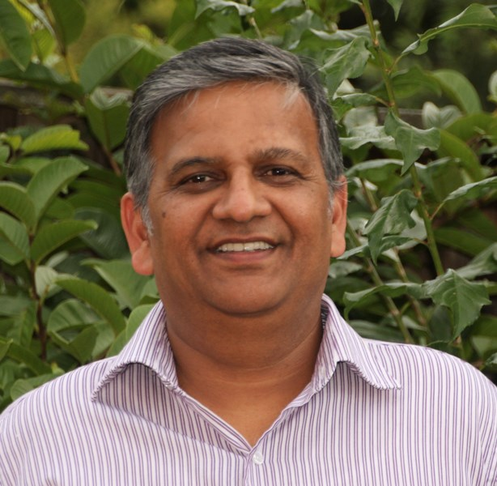
CCP volunteers are PMI members just like you, and our goal is to provide mentoring and advice that can make NFPs more efficient by:
- Encouraging PM practices so NPFs can better understand and explore how project management can assist
- Mentoring NPF leaders who can further develop and apply PM skills to their work
- Health-check existing projects and review current practices to assess NFP organisations’ PM maturity
Having been a part of CCP initiatives over the last year, I have found it to be a personally rewarding experience. Unlike working in some corporate environments, there is a real appetite for the benefits that project management can provide and we have seen groups enthusiastically embrace PM practices to improve their services.

Our team has had several successful engagements with NFPs in the past year and having some exciting plans for this year. Recent assignments include:
- Chrys Bekaris mentored Sharing Stories Foundation, an organisation which supports the maintenance and strengthening of Aboriginal and Torres Strait Island cultures and languages.
- Glen Molloy collaborated with the Jack Thompson Foundation, which addresses unemployment and housing shortage by teaching indigenous Australians to build houses out of natural resources.
- Arthur Karbala worked with the House of Welcome, the volunteering organisation that provides housing accommodation for asylum seekers.
These dedicated volunteers gave their time and transferred their knowledge to these NFPs as a way of giving back to the community. You may consider joining us and doing something that will give you the satisfaction of knowing that many others can benefit from your efforts.
Certainly we are looking at ramping up our efforts and the effectiveness of the CCP this year. Late last year, our current president and last year’s BBF Director, Julia Checchia, arranged a presentation of our vision to the Centre of Volunteer Organisation. In that session, entitled Project Management as a lifestyle and the benefits to NFPs, I along with fellow volunteers, Steve Christolis and Hugo Ribeiro had the opportunity to deliver the PM message to representatives from over 10 volunteer organisations. Many of them were excited and have expressed their interest in using our CCP services in the very near future.
A tangible outcome of that session was that the Exodus Foundation , a Sydney based NFP that combats disadvantage in its many forms by providing food, and educational, and health and wellbeing services to those who need it most, requested our support. Maryam Shahrestani took the lead in supporting their Connected Communities project and assisted by creating the project deliverables in accordance with PMBOK. This partnership developed to the extent that Bill Crew, the founder of the Exodus Foundation, invited Julia Checchia to discuss further ideas for PMI support. Upcoming events with Exodus include introductory training on project management and a review of their Strategic Project Portfolio.
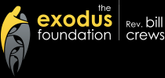
The partnership with PMI has been awesome. The Exodus foundation got direction on the project management process. This resulted in the successful implementation of network to serve us to serve in unique ways.
Peter Valpiani – Manager Business Services
In parallel, we will be working with Volunteering Australia to leverage our experiences at the Exodus Foundation and create a CCP services template that can be applied to other NFPs. The best part is that our role will help an organization identify their projects and specify resource requirements so corporate volunteers and university students can help execute their strategic vision. The end result is that NFPs can utilize the skills and expertise offered by volunteers, not merely using them for routine jobs. Such skills matching ensure both corporate and individual volunteers, as well as the NFPs, will have a more rewarding engagement.
Not only does this partnership with PMI offer benefits to the NFP sector it supports the Centre’s peak body activities.
Tony Frew – General Manager

We hope the above has sparked your interest in helping us in the CCP and our broader BBF outreach mission. If you would like to be involved with this exciting program, do let us know by emailing us at ccp@pmisydney.org

Ram Viswanathan

